APPENDIX C3: Assessment for authors

Introduction
This appendix seeks to provide further examples of possible questions which are there to help authors to prepare for their online courses. These are to be used in conjunction with three short documents:
- A downloadable template, on which to model your answers
- one page checklist for assessment questions
- one page checklist for academic writing in general.
These are provided in the general section of your teams area for your online course.
You will also find up to date information about the role of authors and the timeline for development.
There is also a short welcome video from Prof Eric Hachulla, the Scientific Organiser for all Eular online courses, welcoming new authors and thanking you all for your contributions to Eular.
Authors are invited to a biannual event to support their course team working and to develop their assessments. There are slides and online recordings of this event in Budapest, 2018, on the Eular Website, for your guidance.

It is particularly important that all questions are asked within a clinical context.
There is a presentation by Prof Jose da Silva online, recorded at the Budapest event, which further examples and explanation of how to engage learners effectively in the clinical context.

Examples of question types
Authors are asked to use only the following 2 types of questions, multiple choice questions (MCQs) and extended matching questions and (EMQs).

NB: “True/False” or “Yes/No” dichotomous questions are no longer recommended for advanced clinical assessments.

Multiple Choice or single best answer 1 out of 5 or 2 out of 7
Multiple choice questions, involve choosing one or two correct answers from a list of five or seven options, containing incorrect choices or distractors. The incorrect answers should be plausible and appear similar in detail to the correct answer. Base the question (s) on a short, clinical context for each question. To reduce the amount of reading necessary for testing, try to keep the clinical context below 75 words or use as the basis for more than one question. Include only the most relevant information. If the question could still be answered without reading the clinical context, you need to rewrite it.

MCQ Example: 1 from 5
A 76-year-old lady is admitted to hospital with abdominal pain and undergoes surgery for a strangulated femoral hernia. She had previously been well and was on no drugs apart from omeprazole 20mg daily as required for intermittent dyspepsia, and bendrofluazide 5 mg daily for the past year for bilateral ankle swelling. She had previously been well.
There were no surgical complications but on her 3rd post-operative day she develops an acutely painful swollen right knee and feels a little unwell. She had never before experienced acute swelling of any joint.
On examination she has a warm effusion, marked joint-line and periarticular tenderness and overlying erythema of her right knee; it is too painful to fully examine movement. Her left knee shows patello-femoral crepitus, bony swelling of the tibio-femoral margins, a bulge sign and reduced flexion and extension without stress pain. Her temperature is 38.4° C.

Specify the single most likely diagnosis
Acute pyrophosphate arthritis (pseudogout) | [YES]
Acute gout | [NO]
Acute reactive arthritis | [NO]
Exacerbation (“flare”) of knee osteoarthritis | [NO]
Septic arthritis | [NO]

Example Feedback
Rapid onset of severe pain, swelling and overlying that is at its worst within 6-12 hours is very characteristic of crystal synovitis – gout or pseudogout. Intercurrent illness such as surgery can provoke acute attacks of crystal synovitis. Either gout or pseudogout, pseudogout is the more likely because:
- she has been on diuretics for just 6 months (short for predisposition to gout)
- she has knee OA - this associates with CPPD deposition
- the knee is the key target joint for pseudogout
After crystal synovitis, septic arthritis requires consideration in this setting. However, septic arthritis is usually subacute and progressive in its presentation.

MCQ Example 2 out of 7:
Stem:
Janet has suffered from rheumatoid arthritis (RA) for many years. She also suffers from psychological distress. She was therefore referred to a psychologist for psychological assessment. One of the tests performed by the psychologist was a personality test. One of the conclusions in the test report is that Janet’s personality is characterised by a high degree of neuroticism (proneness to negative emotions) and by a self-sacrificing defence style.

Question number:
Select the two statements that are correct. (2 correct answers)

7 similar, plausible options of which two are correct (2 answers)
1. Janet’s personality, characterised by a high degree of neuroticism and by a self- sacrificing defence style, is very typical for RA patients and may be an important aetiological factor for her RA
2. Neuroticism has been indicated to negatively influence the perception of symptoms and wellbeing in RA.
3. Patients with a self- sacrificing defence style such as Janet may be particularly vulnerable to experience more symptoms.
4. Sixty years ago it was quite uncommon to associate RA with personality factors. In later years the emphasis on personality factors have increased.
5. There is solid empirical evidence for the “Arthritis Personality” concept.
6. Low extraversion is more characteristic for patients with RA than high neuroticism.
7. High hostility is the more characteristic personality characteristic of patients with RA.

Clear statement of 2 correct answers
Correct answers:
2. Neuroticism has been indicated to negatively influence the perception of symptoms and wellbeing in RA.
3. Patients with a self- sacrificing defence style such as Janet may be particularly vulnerable to experience more symptoms.

Feedback:
- Wrong answer. There is no evidence for personality factors in the aetiology of RA.
- Correct answer. Patients with high neuroticism scores may report more discomfort associated with symptoms than other patients.
- Correct answer. Patients with a self- sacrificing defence style report more severe symptoms.
- Wrong answer. RA was by some clinicians, such as Franz Alexander, characterised as a psychosomatic disease in the 1950s. The emphasis on personality as an etiological factor in RA has decreased over the years, but there is an increased evidence of the significance of psychological factors in how well patients cope with the disease.
- The “Arthritis Personality” concept was popular in the 1950s and 60s, but the concept has limited empirical support.
- Wrong answer. Personality of patients with RA is on average comparable to personality of people in the general population.
- Wrong answer. Personality of patients with RA is on average comparable to personality of people in the general population.

Extended Matching
Extended matching questions involve matching elements of a shorter list (3 – 5 options) with elements of a longer list (7-9). Usually the longer list consists of drugs, named diseases, conditions, diagnoses, treatments, etc., and the shorter list consists of presenting features or clinical case descriptions. The longer list should be at least twice as long as the shorter list.
This is an excellent format for flexibility in testing knowledge using the minimum of words and new questions from the examiner and relates closely to the clinical context. Highly recommended!

EMQ Example 1
The following patients all have arthritis. Select the most appropriate diagnosis of arthropathies in cases A, B, C associated with characteristic patterns of joint involvement (1-9) from the list below.
- psoriatic arthritis
- rheumatoid arthritis
- haemochromatosis
- chronic tophaceous gout
- ankylosing spondylitis
- nodal generalised osteoarthritis
- pyrophosphate arthropathy
- neuropathic (Charcot) arthropathy
- reactive arthritis
A.
A 65-year-old man developed relapsing attacks of acute arthritis in his forties, initially affecting his forefoot, midfoot or ankle. Over many years they became more frequent and spread to also involve his knees and hands. Each episode affects just one joint, develops within hours, causes severe pain and swelling, and lasts 1-2 weeks. In the last 15 years he has also developed chronic pain and stiffness of his forefeet, ankles, knees, fingers, wrists and elbows. He has swellings over his hands, elbows and knees.
[ 4 ]
B.
Over a 2-week period a 22-year-old woman developed pain, stiffness and swelling of her right knee, left ankle and big toe. She has right knee synovitis, synovitis and periarticular swelling of her left ankle and midfoot and synovitis of her big-toe interphalangeal joint. The only other abnormalities are two large (painless) buccal ulcers. [ 9]
C
A 37-year-old woman gives a 6-month history of pain and stiffness affecting several finger proximal interphalangeal and metacarpophalangeal joints, both wrists, both elbows, left knee, and both forefeet. She has several hours of early morning stiffness, has lost 6kg in weight and feels tired. She has synovitis of her symptomatic hand joints, wrists, elbows and knees. There are no extra-articular signs.
[ 2 ]

EMQ Example 2
Match the clinical histories of patients with arthritis (Cases A, B, C ) with the most likely clinical diagnoses of arthropathies associated with characteristic patterns of joint involvement (1-11). (Extended Matching: 3 marks)

Diagnoses
- psoriatic arthritis
- rheumatoid arthritis
- haemochromatosis
- chronic tophaceous gout
- ankylosing spondylitis
- nodal generalised osteoarthritis
- pyrophosphate arthropathy
- neuropathic (Charcot) arthropathy
- reactive arthritis
- Gonococcal arthritis
- Behçet’s disease
Case A.
A 65-year-old man developed relapsing attacks of acute arthritis in his forties, initially affecting his forefoot, midfoot or ankle. Over many years they became more frequent and spread to also involve his knees and hands. Each episode affects just one joint, develops within hours, causes severe pain and swelling, and lasts 1-2 weeks. In the last 15 years he has also developed chronic pain and stiffness of his forefeet, ankles, knees, fingers, wrists and elbows. He has nodular swellings over his hands, elbows and knees. [ 4 ]

Case B.
Over a 2-week period a 22-year-old woman developed pain, stiffness and swelling of her right knee, left ankle and big toe. She has right knee synovitis, synovitis and periarticular swelling of her left
ankle and midfoot and synovitis of her big-toe interphalangeal joint. The only other abnormalities are two large (painless) buccal ulcers. [ 9 ]

Case C
A 37-year-old woman gives a 6-month history of pain and stiffness affecting several finger proximal interphalangeal and metacarpophalangeal joints, both wrists, both elbows, left knee, and both forefeet. She has several hours of early morning stiffness, has lost 6kg in weight and feels tired. She has synovitis of her symptomatic hand joints, wrists, elbows and knees. There are no extra-articular signs. [ 2 ]

Consequential help
When writing case-based questions avoid providing information in the latter part of the case that can be used to answer earlier questions. For example a latter section of the case should not state a specific diagnosis that is the answer to an earlier question.

Use of images in questions
Using on-line assessments it is possible to use a variety of images such as x-rays, photographs and diagrams as items in questions. These can be used as contexts for questions or they can form the basis of identification or diagnostic questions. Alternatively images can appear in Extended Matching questions as shown in the example below. Here the use of ‘Image Hotspots’ is demonstrated where a specific area of the image is the focus of the question. When submitting questions that use image hotspots it will be necessary to outline the area or areas of the image that are the focus of questions and to communicate this information to the question programmer. 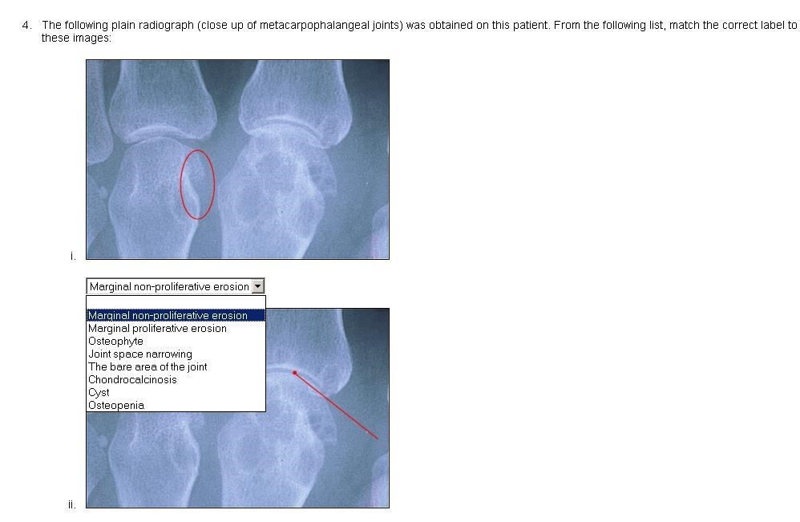

Reference:
Constructing written test questions for the basic and clinical sciences. Case & Swanson (2001)
Download free of charge as a PDF file from: https://www.nbme.org/pdf/itemwriting_2003/2003iwgwhole.pdf

